**Name: Asmaa Mostafa kamal**

**B.N: 190**

**Date : 1/6/2020**

**Topic:** Operating systems

**Github link:** <https://github.com/Asmaa419/Operating-Systems->

**Github page:** <https://asmaa419.github.io/Operating-Systems-/>

**Application brief: The operating system sits in between the applications you run and the hardware, using the hardware drivers as the interface between the two . An operating system is the core set of software on a device that keeps everything together. There are many operating systems, each with features and uses**

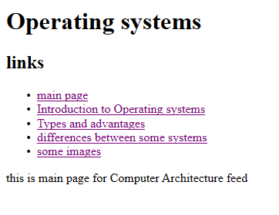**Screenshots:**

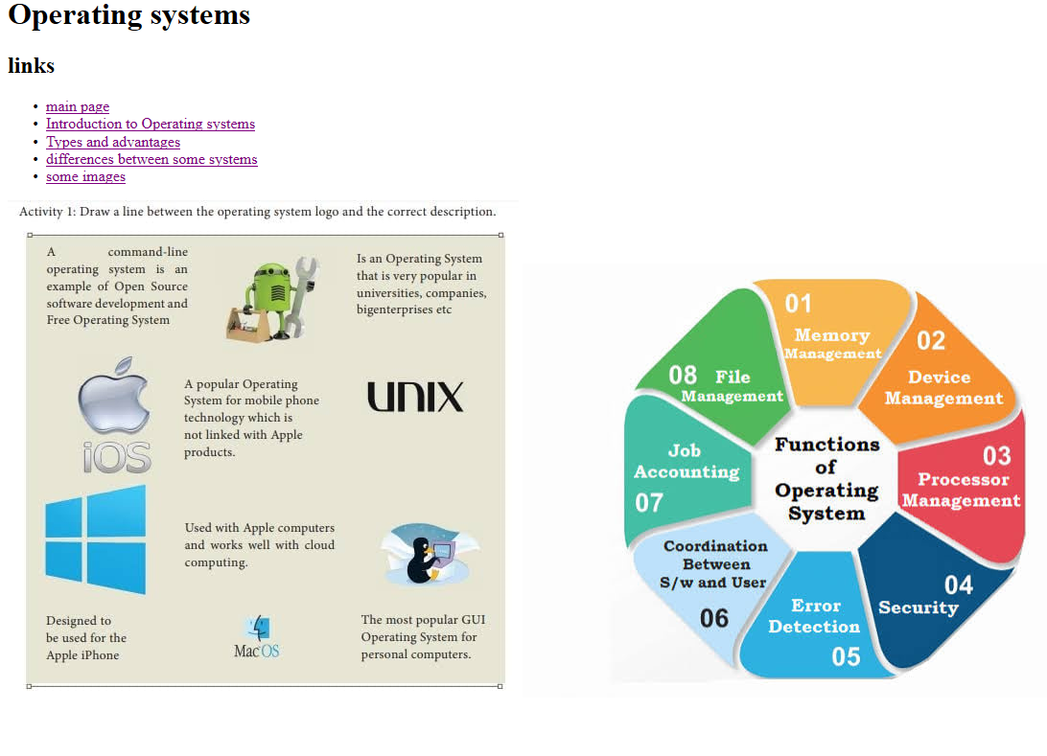

**Source code:**

